# Mail merge using an Excel spreadsheet

Here are some tips to prepare your Excel spreadsheet for a mail merge. Make sure:

Column names in your spreadsheet match the field names you want to insert in your mail merge. For example, to address readers by their first name in your document, you'll need separate columns for first and last names.

All data to be merged is present in the first sheet of your spreadsheet.

Data entries with percentages, currencies, and postal codes are correctly formatted in the spreadsheet so that Word can properly read their values.

The Excel spreadsheet to be used in the mail merge is stored on your local machine.

Changes or additions to your spreadsheet are completed before it's connected to your mail merge document in Word.

## Connect and edit the mailing list

### Edit your mailing list

Choose Edit Recipient List.

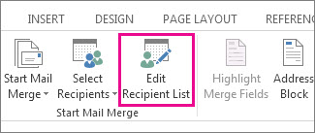

In **Mail Merge Recipients**, clear the check box next to the name of any person who you don't want to receive your mailing.

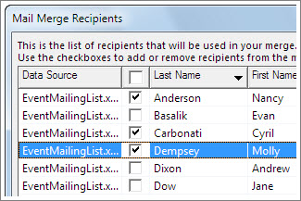

[Insert a merge field](javascript:)

You can insert one or more mail merge fields that pull the information from your spreadsheet into your document.

**To insert merge fields on an envelope, label, email message, or letter**

Go to **Mailings** > **Address Block**.

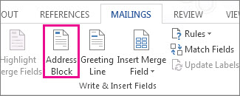

To add a greeting line, choose **Greeting Line**.

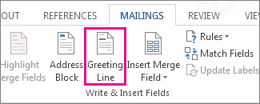

To add other merge fields, like invoice numbers, see [Insert mail merge fields](https://support.microsoft.com/en-us/office/insert-mail-merge-fields-9a1ab5e3-2d7a-420d-8d7e-7cc26f26acff).

Choose **OK**.

Choose **File** > **Save**.

## [Preview and finish the mail merge](javascript:)

After you insert the merge fields you want, preview the results to confirm that the content is okay. and then you're ready to complete the merge process.

Go to Mailings> Preview Results.

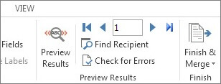

Choose **Next** Next record button for mail merge preview results or **Previous** Previous record button for mail merge preview results to move through records in your data source and view how they appear in the document.

Go to **Finish & Merge** > **Print Documents** or **Send E-mail Messages**.

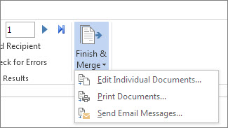

[Save your mail merge](javascript:)

When you save the mail merge document, it stays connected to your data source. You can reuse the mail merge document for your next bulk mailing.

Open the mail merge document and choose **Yes** when Word prompts you to keep the connection.